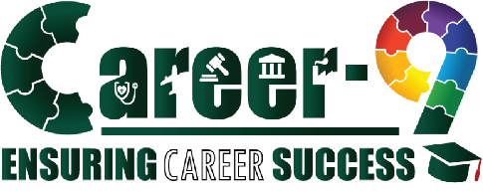


{{ name_caps }}’S
NAVIGATOR
REPORT


{{ school }}
School Name
{{ class }}
{{ name }}
Student Details:
Grade
Name

{{ one_pager_summary }}

Your full report is waiting—unlock it now by clicking here and take the next step toward your ideal career!



Career-9:



NAVIGATOR 360:









5
8
9
11
11


LOGICAL
12
11
Uttam’s INTELLIGENCE PROFILE

Uttam’s Learning Style

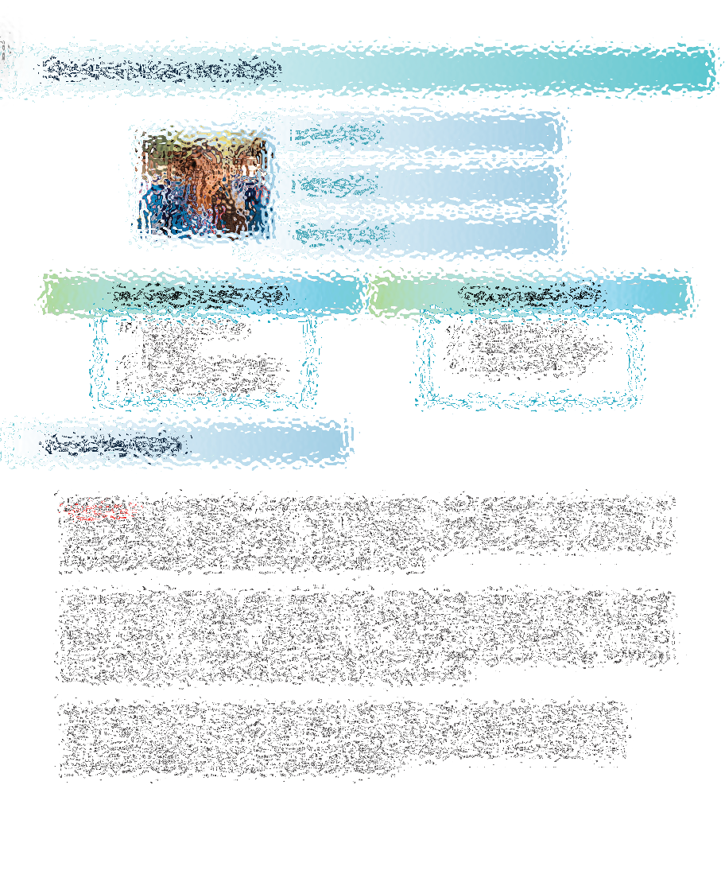

UTTAM’s Preferences



Uttam’s Career Suitability Index:

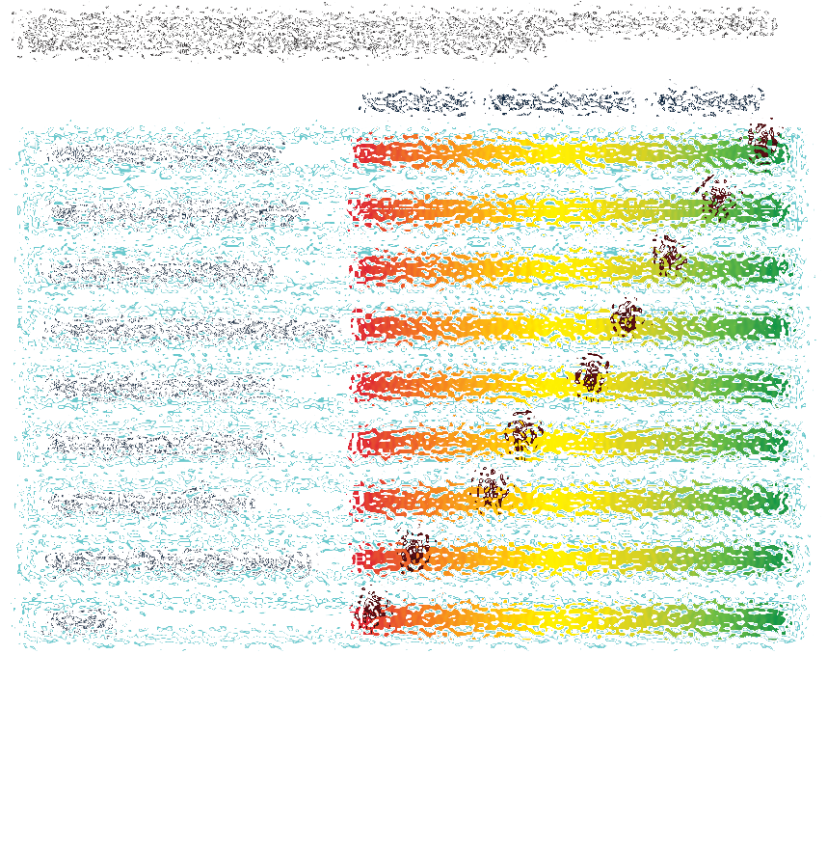

Frequently Asked Questions

- What if my pathway does not match with my subject knowledge?
{{ f_name }}, there can be various reasons for a lack of subject knowledge in one's aspired career. It could be due to a rapid pace of technological advancements outpacing one's current knowledge, or even a lack of exposure to relevant career activities that build such knowledge. Additionally, self-efficacy, which is the belief in one's ability to succeed, plays a significant role. Studies have shown that individuals with higher self-efficacy are more likely to acquire and apply career-related knowledge effectively. Therefore, addressing these factors through targeted education, training, and confidence-building activities can help bridge the knowledge gap.
- What if my pathway does not match with ability ?
Common factors include a mismatch of skills, lack of exposure, or not having a clear understanding of the career's requirements. It's important to assess one's strengths and weaknesses, seek feedback, and consider additional training or education. Sometimes, it's also about gaining more hands-on experience or finding a mentor to guide you through the industry. Remember, career paths are rarely linear, and it's never too late to acquire new skills or change direction.
- What if my pathway does not match with my values?
Sometimes, a lack of clarity about personal values or how they can influence professional environment can lead to uncertainty in career direction. It's important to reflect on what you find meaningful and fulfilling, whether it's materialistic achievements, people-oriented needs, making a positive societal impact, or seeking a sense of purpose. Understanding these core values can guide you towards a career that resonates with your beliefs and goals. If you're experiencing a disconnect, it might be beneficial to explore various aspects of your life and career to pinpoint values that are truly important to you.
- What if there is no dominant personality trait?
Don’t worry! not having a dominant personality trait can be due to various factors. One possible reason could be that you may exhibit ‘traits’ from ‘multiple traits’ which are not fully explored, which makes a single category less definitive. Additionally, cultural and environmental factors can influence your preferences, which the model might not fully account for. Or sometimes there are other personal or mental health challenges that make it difficult to shine in one area.
Our expert psychologist and a team of career counselors is just a call away to help you reach your full potential and become the best version of yourself.

